Prototype: from a survey question to a game
Take one conventional research question and demonstrate how you would transform it into a more reliable, engaging and gamified experience.

The original question
I started looking at protein because it's everywhere right now. My Instamart feed is full of protein wafers, protein chips and even protein namkeen, and whenever I order something these days, I end up picking the protein-rich option.
I came across two surveys from this year that don't really agree with each other.
The first is the Farmley Healthy Snacking Report 2026. It found that 86% of people now consider protein an important factor when choosing snacks, which it reads as a broader shift towards healthier, more functional eating (ANI News).
The second is the India's Protein Gap survey (India's Protein Gap). It found that:
- 6 in 10 urban Indians don't eat protein-rich foods daily
- around 85% keep no record or estimate of their protein intake
- nearly three-quarters couldn't say how much protein an adult needs
- people named affordability as the main barrier, and 71% said they'd switch to cheaper protein options
So which is it? Either 86% of us care about protein and most of us still don't act on it, or the 86% isn't measuring what it seems to measure. I think it's mostly the second. To understand why, I looked at the kind of question that sits behind headlines like this:
“When choosing a snack, how important is protein content to you?” (1 = not at all important, 5 = very important)
I picked it because it's one of the most common question formats brands use, so a protein-snack brand could easily ask it tomorrow. The problem is that saying protein matters costs nothing and sounds good, so most people answer 4 or 5 whatever they actually buy.

My redesigned question and rationale
“It's 4:30pm, you're at your desk and hungry. Which one would you buy?”
- Masala chips · ₹20 · 3g protein
- Chocolate protein bar · ₹90 · 20g protein
- Masala peanuts · ₹40 · 8g protein
This is just one round. One choice on its own could be random, but several choices show a pattern, for example “picks protein after the gym, but chips late at night”. So the game asks between 4 and 10 rounds and stops as soon as the pattern is clear. Each round brings a different snack moment (after the gym, a late-night craving, a road trip, before a meeting) and a different mix of protein, taste and price, and the next round is picked to learn the most about that player. At the end, I ask what they actually bought last time, and only then the original 1–5 question.
Rationale. The original question asks people to rate protein. The redesign makes them choose a snack. Protein is easy to value when it costs nothing, but when it means giving up taste or paying ₹70 more, we find out whether it really matters. This works better than the 1–5 rating because it is:
- Behavioural: every round is a real snack moment with real prices, so the answer is close to an actual purchase.
- Psychometric: many small trade-offs show how much protein really matters, when it wins, and at what price.
- Less biased: there's no “right” answer, all cards look the same and are shuffled, a repeated round and an overpriced twin catch mindless tapping, and rushing is checked against reading time.
- Said vs done: the 1–5 rating comes last, so we can compare what people say with what they choose, and ask one follow-up question about the biggest gap.

The gamified interaction
Snack Moments is the core of the game, but it sits inside a short journey of about three minutes. Players start with two quick warm-ups (a glance-and-recall round and fast swipes), play the adaptive Snack Moments rounds, and get two bonus games picked to suit them. Then they guess what other people chose, tell us their last real purchase, give the 1–5 rating and answer one follow-up question, before seeing a results card with their snack type. Points reward careful play and good guesses, never a particular answer, so the game never pushes people towards protein.
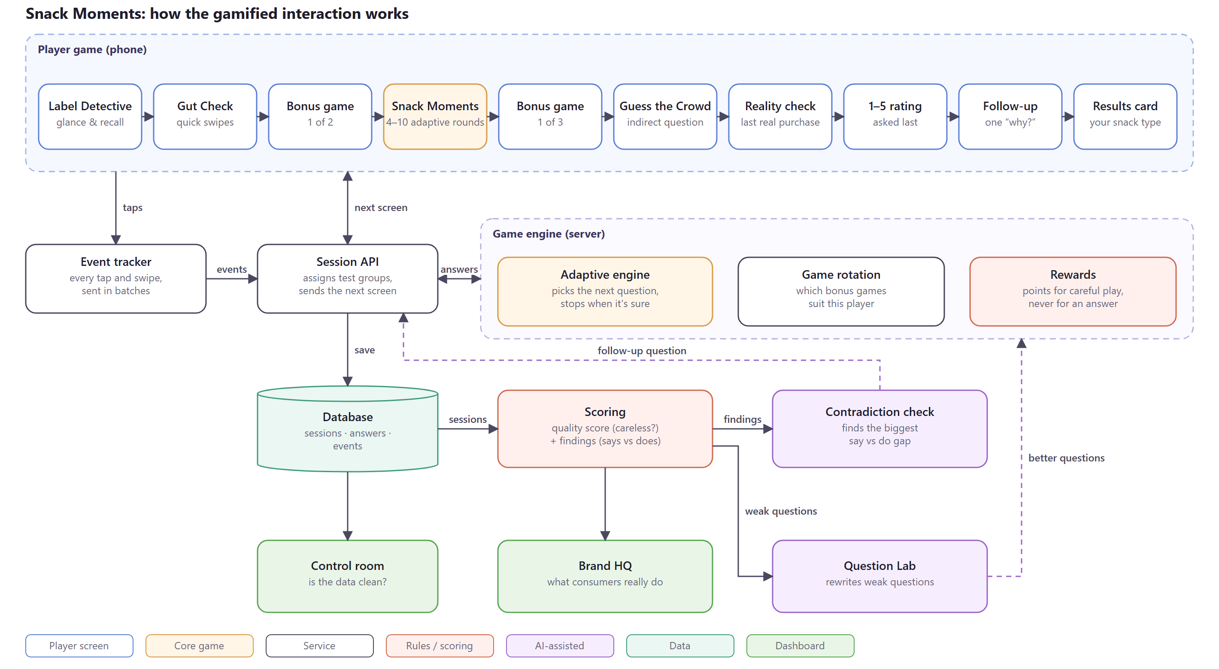
How the gamified interaction works (editable version: gamified-interaction-architecture.drawio)

What behavioural insight it captures
The game is designed to show what people do when protein has a cost, not what they say about it. From the same three minutes of play it captures:
- What protein is really worth: how many extra rupees per gram of protein each person will pay, and how that changes between moments (at the desk, after the gym, late at night).
- What drives each person: whether their choices are led by price, taste or protein, or switch depending on the moment.
- The say vs do gap: how far the 1–5 rating sits from what their choices show, and, from the follow-up question, why (price, taste, or just not hungry).
- What people notice: whether protein is even seen on a pack, compared with price.
Together this answers the question the two surveys couldn't: whether people who say protein matters actually pay for it, when they do, and what stops them when they don't.

